THE HISTORY OF THE OLD JUDDIAN RUGBY FOOTBALL CLUB
1927 to 1999

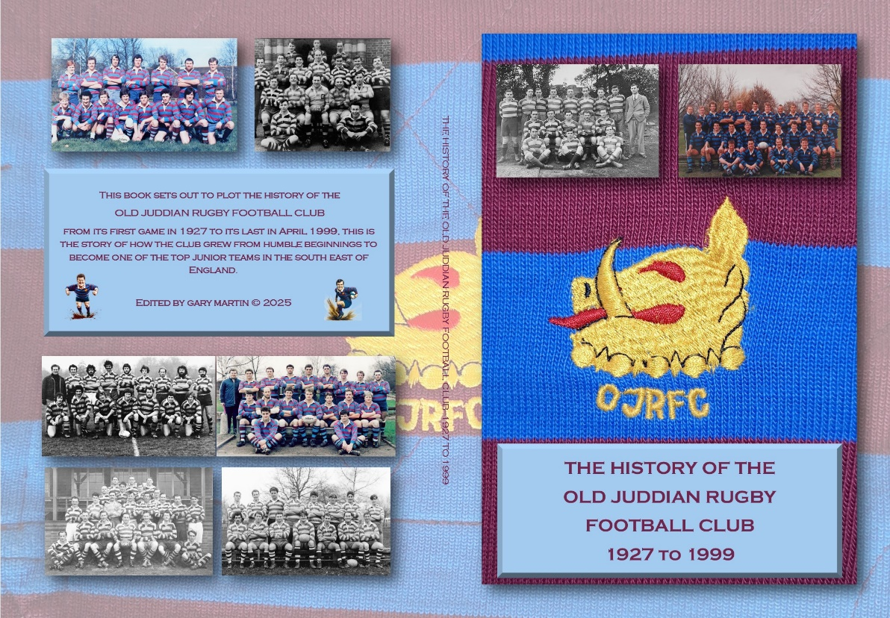

Before all the memories fade to dust it was thought prudent to chart the history of the OJRFC. To that end, and after extensive research, a commemorative book has been produced – the picture above shows the opened out cover (book size 240mm high x 170mm wide)
The book is 120 pages long and packed with photos, results and anecdotes from the 70 years of the club’s existence. It charts the club’s progress from one team ‘playing off a park bench’, through the growth in the 1960’s, the heady successes of the 1980’s, to the OJRFC eventually selecting six sides a week. The book follows a year-by-year timeline, with photos from each era and personal anecdotes from former players.
The launch date for the book is April 2025 and anyone interested in obtaining a copy of this limited edition print run should contact Gary Martin – contact details below. The price of the book is £15 per copy; for UK postage please add an additional £3.50.
To order your copy please contact Gary by e-mail to garytmartin@btinternet.com, by phone on 07801 682580 or write to 18 Pinkham, East Peckham, Tonbridge TN12 5EU. Payment preferred by bank transfer but cheque or cash payments acceptable.
Copies of the book will be available to purchase at the last TJ’s home again of the season on 12th April (vs Oxford Harlequins).


